Gesture Recognition Experiment Log

**Fixed for All Experiments**

num_train_sequences = 663

num_val_sequences   = 100

num_classes=5

loss='categorical_crossentropy',

metrics=['categorical_accuracy']

**CNN Experiments**

Experiments 1

**Jupyter_file name:** Neural_Nets_Project_Starter_Code1.1

Decision/ Explanation:

Image Size = 100x100

Batch Size = 5

img_idx = random 10 images from each sequence

num_epochs = 5

Take only 15 videos for training

**Architecture**

model.add(Conv3D(32, (2, 3, 3), padding='same', input_shape=(imgs_from_1video, imsize[0],imsize[1],3)))

model.add(Activation('relu'))

model.add(Conv3D(32, (2, 3, 3), padding='same'))

model.add(Activation('relu'))

model.add(MaxPooling3D(pool_size=(2, 2, 2)))

model.add(Dropout(0.25))

model.add(Conv3D(64, (2, 3, 3), padding='same'))

model.add(Activation('relu'))

model.add(Conv3D(64, (2, 3, 3), padding='same'))

model.add(Activation('relu'))

model.add(MaxPooling3D(pool_size=(2, 2, 2)))

model.add(Dropout(0.25))

model.add(Flatten())

model.add(Dense(512))

model.add(Activation('relu'))

model.add(Dropout(0.5))

model.add(Dense(num_classes))

model.add(Activation('softmax'))

Resutls

Training Accuracy: 20%

Experiments 2

**Jupyter_file name:** Neural_Nets_Project_Starter_Code1.2

**Decision/ Explanation:**

Image Size = 80x80

Batch Size = 10

img_idx = random 15 images from each sequence

num_epochs = 10

Take only 15 videos for training

Results

Training Accuracy: 20%

Experiments 3

**Jupyter_file name:** Neural_Nets_Project_Starter_Code1.3

**Decision/ Explanation:**

Image Size = 80x80

Batch Size = 10

img_idx = random 15 images from each sequence

num_epochs = 10

Take only 15 videos for training

Results

Training Accuracy: 20%

Experiments 4

**Jupyter_file name:** Neural_Nets_Project_Starter_Code1.3

**Decision/ Explanation:**

Add CONV3D 3rd Layer of 128 neurons

**Architecture**

model.add(Conv3D(32, (2, 3, 3), padding='same', input_shape=(imgs_from_1video, imsize[0],imsize[1],3)))

model.add(Activation('relu'))

model.add(Conv3D(32, (2, 3, 3), padding='same'))

model.add(Activation('relu'))

model.add(MaxPooling3D(pool_size=(2, 2, 2)))

model.add(Dropout(0.25))

model.add(Conv3D(64, (2, 3, 3), padding='same'))

model.add(Activation('relu'))

model.add(Conv3D(64, (2, 3, 3), padding='same'))

model.add(Activation('relu'))

model.add(MaxPooling3D(pool_size=(2, 2, 2)))

model.add(Dropout(0.25))

model.add(Conv3D(128, (2, 3, 3), padding='same'))

model.add(Activation('relu'))

model.add(Conv3D(128, (2, 3, 3), padding='same'))

model.add(Activation('relu'))

model.add(MaxPooling3D(pool_size=(2, 2, 2)))

model.add(Dropout(0.25))

model.add(Flatten())

model.add(Dense(512))

model.add(Activation('relu'))

model.add(Dropout(0.5))

model.add(Dense(num_classes))

model.add(Activation('softmax'))

Results

Training Accuracy: 21%

Experiments 5

**Jupyter_file name:** Neural_Nets_Project_Starter_Code1

**Decision/ Explanation:**

num_epochs = 50

Other Parameters

Image Size = 128x128

Batch Size = 60

img_idx = np.array( range(0,30,3))

num_epochs = 50

optimiser = "adam"

Normalization

steps_per_epoch = int(num_train_sequences/batch_size) => 12

validation_steps = int(num_val_sequences/batch_size)  => 2

**Results**

Experiments - 6

Jupyter_file name: Neural_Nets_Project_Starter_Code2

**Decision/ Explanation:**

Batch Size = 40

num_epochs = 100

**Other Parameters**

Image Size = 128x128

Batch Size = 40

img_idx = np.array( range(0,30,3)) #10 images

num_epochs = 100

optimiser = "adam"

steps_per_epoch = int(num_train_sequences/batch_size) => 17

validation_steps = int(num_val_sequences/batch_size)  => 2

**Architecture**

model.add(Conv3D(32, (2, 3, 3), padding='same', input_shape=(imgs_from_1video, imsize[0],imsize[1],3)))

model.add(Activation('relu'))

model.add(Conv3D(32, (2, 3, 3), padding='same'))

model.add(Activation('relu'))

model.add(MaxPooling3D(pool_size=(2, 2, 2)))

model.add(Dropout(0.25))

model.add(Conv3D(64, (2, 3, 3), padding='same'))

model.add(Activation('relu'))

model.add(Conv3D(64, (2, 3, 3), padding='same'))

model.add(Activation('relu'))

model.add(MaxPooling3D(pool_size=(2, 2, 2)))

model.add(Dropout(0.25))

model.add(Conv3D(128, (2, 3, 3), padding='same'))

model.add(Activation('relu'))

model.add(Conv3D(128, (2, 3, 3), padding='same'))

model.add(Activation('relu'))

model.add(MaxPooling3D(pool_size=(2, 2, 2)))

model.add(Dropout(0.25))

model.add(Flatten())

model.add(Dense(512))

model.add(Activation('relu'))

model.add(Dropout(0.5))

model.add(Dense(num_classes))

model.add(Activation('softmax'))

Architecture

_________________________________________________________________

Layer (type) Output Shape Param #

=================================================================

conv3d_1 (Conv3D) (None, 10, 128, 128, 32) 1760

_________________________________________________________________

activation_1 (Activation) (None, 10, 128, 128, 32) 0

_________________________________________________________________

conv3d_2 (Conv3D) (None, 10, 128, 128, 32) 18464

_________________________________________________________________

activation_2 (Activation) (None, 10, 128, 128, 32) 0

_________________________________________________________________

max_pooling3d_1 (MaxPooling3 (None, 5, 64, 64, 32) 0

_________________________________________________________________

dropout_1 (Dropout) (None, 5, 64, 64, 32) 0

_________________________________________________________________

conv3d_3 (Conv3D) (None, 5, 64, 64, 64) 36928

_________________________________________________________________

activation_3 (Activation) (None, 5, 64, 64, 64) 0

_________________________________________________________________

conv3d_4 (Conv3D) (None, 5, 64, 64, 64) 73792

_________________________________________________________________

activation_4 (Activation) (None, 5, 64, 64, 64) 0

_________________________________________________________________

max_pooling3d_2 (MaxPooling3 (None, 2, 32, 32, 64) 0

_________________________________________________________________

dropout_2 (Dropout) (None, 2, 32, 32, 64) 0

_________________________________________________________________

conv3d_5 (Conv3D) (None, 2, 32, 32, 128) 147584

_________________________________________________________________

activation_5 (Activation) (None, 2, 32, 32, 128) 0

_________________________________________________________________

conv3d_6 (Conv3D) (None, 2, 32, 32, 128) 295040

_________________________________________________________________

activation_6 (Activation) (None, 2, 32, 32, 128) 0

_________________________________________________________________

max_pooling3d_3 (MaxPooling3 (None, 1, 16, 16, 128) 0

_________________________________________________________________

dropout_3 (Dropout) (None, 1, 16, 16, 128) 0

_________________________________________________________________

flatten_1 (Flatten) (None, 32768) 0

_________________________________________________________________

dense_1 (Dense) (None, 512) 16777728

_________________________________________________________________

activation_7 (Activation) (None, 512) 0

_________________________________________________________________

dropout_4 (Dropout) (None, 512) 0

_________________________________________________________________

dense_2 (Dense) (None, 5) 2565

_________________________________________________________________

activation_8 (Activation) (None, 5) 0

=================================================================

Total params: 17,353,861

Trainable params: 17,353,861

Non-trainable params: 0

_________________________________________________________________

None

**Results**

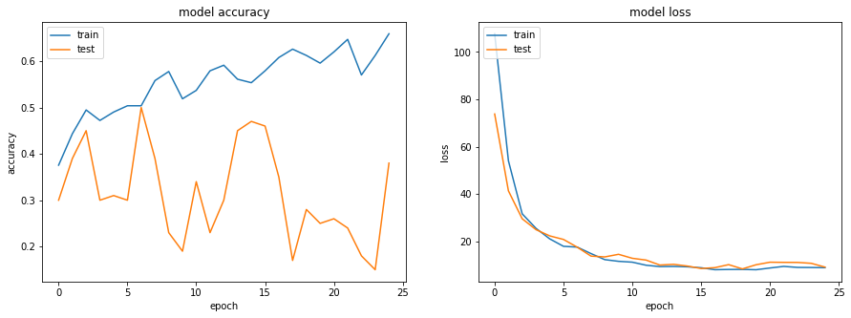

Experiments - 7

**Jupyter_file name:** Neural_Nets_Project_Starter_Code3

**Decision/ Explanation:**

num_epochs = 50 (reduced)

Added BatchNormalization in Architecture

**Other Parameters**

Image Size = 128x128

Batch Size = 40

img_idx = np.array( range(0,30,3)) #10 images

num_epochs = 50 (reduced)

optimiser = "adam"

steps_per_epoch = int(num_train_sequences/batch_size) => 17

validation_steps = int(num_val_sequences/batch_size)  => 2

**Architecture**

model = Sequential()

model.add(Conv3D(32, (2, 3, 3), padding='same', input_shape=(imgs_from_1video, imsize[0],imsize[1],3)))

model.add(Activation('relu'))

model.add(BatchNormalization())

model.add(Conv3D(32, (2, 3, 3), padding='same'))

model.add(Activation('relu'))

model.add(BatchNormalization())

model.add(MaxPooling3D(pool_size=(2, 2, 2)))

model.add(Dropout(0.25))

model.add(Conv3D(64, (2, 3, 3), padding='same'))

model.add(Activation('relu'))

model.add(BatchNormalization())

model.add(Conv3D(64, (2, 3, 3), padding='same'))

model.add(Activation('relu'))

model.add(BatchNormalization())

model.add(MaxPooling3D(pool_size=(2, 2, 2)))

model.add(Dropout(0.25))

model.add(Conv3D(128, (2, 3, 3), padding='same'))

model.add(Activation('relu'))

model.add(BatchNormalization())

model.add(Conv3D(128, (2, 3, 3), padding='same'))

model.add(Activation('relu'))

model.add(BatchNormalization())

model.add(MaxPooling3D(pool_size=(2, 2, 2)))

model.add(Dropout(0.25))

model.add(Flatten())

model.add(Dense(512))

model.add(Activation('relu'))

model.add(BatchNormalization())

model.add(Dropout(0.5))

model.add(Dense(num_classes))

model.add(Activation('softmax'))

#write your model here

_________________________________________________________________

Layer (type) Output Shape Param #

=================================================================

conv3d_1 (Conv3D) (None, 10, 128, 128, 32) 1760

_________________________________________________________________

activation_1 (Activation) (None, 10, 128, 128, 32) 0

_________________________________________________________________

batch_normalization_1 (Batch (None, 10, 128, 128, 32) 128

_________________________________________________________________

conv3d_2 (Conv3D) (None, 10, 128, 128, 32) 18464

_________________________________________________________________

activation_2 (Activation) (None, 10, 128, 128, 32) 0

_________________________________________________________________

batch_normalization_2 (Batch (None, 10, 128, 128, 32) 128

_________________________________________________________________

max_pooling3d_1 (MaxPooling3 (None, 5, 64, 64, 32) 0

_________________________________________________________________

dropout_1 (Dropout) (None, 5, 64, 64, 32) 0

_________________________________________________________________

conv3d_3 (Conv3D) (None, 5, 64, 64, 64) 36928

_________________________________________________________________

activation_3 (Activation) (None, 5, 64, 64, 64) 0

_________________________________________________________________

batch_normalization_3 (Batch (None, 5, 64, 64, 64) 256

_________________________________________________________________

conv3d_4 (Conv3D) (None, 5, 64, 64, 64) 73792

_________________________________________________________________

activation_4 (Activation) (None, 5, 64, 64, 64) 0

_________________________________________________________________

batch_normalization_4 (Batch (None, 5, 64, 64, 64) 256

_________________________________________________________________

max_pooling3d_2 (MaxPooling3 (None, 2, 32, 32, 64) 0

_________________________________________________________________

dropout_2 (Dropout) (None, 2, 32, 32, 64) 0

_________________________________________________________________

conv3d_5 (Conv3D) (None, 2, 32, 32, 128) 147584

_________________________________________________________________

activation_5 (Activation) (None, 2, 32, 32, 128) 0

_________________________________________________________________

batch_normalization_5 (Batch (None, 2, 32, 32, 128) 512

_________________________________________________________________

conv3d_6 (Conv3D) (None, 2, 32, 32, 128) 295040

_________________________________________________________________

activation_6 (Activation) (None, 2, 32, 32, 128) 0

_________________________________________________________________

batch_normalization_6 (Batch (None, 2, 32, 32, 128) 512

_________________________________________________________________

max_pooling3d_3 (MaxPooling3 (None, 1, 16, 16, 128) 0

_________________________________________________________________

dropout_3 (Dropout) (None, 1, 16, 16, 128) 0

_________________________________________________________________

flatten_1 (Flatten) (None, 32768) 0

_________________________________________________________________

dense_1 (Dense) (None, 512) 16777728

_________________________________________________________________

activation_7 (Activation) (None, 512) 0

_________________________________________________________________

batch_normalization_7 (Batch (None, 512) 2048

_________________________________________________________________

dropout_4 (Dropout) (None, 512) 0

_________________________________________________________________

dense_2 (Dense) (None, 5) 2565

_________________________________________________________________

activation_8 (Activation) (None, 5) 0

=================================================================

Total params: 17,357,701

Trainable params: 17,355,781

Non-trainable params: 1,920

_________________________________________________________________

None

**Results**

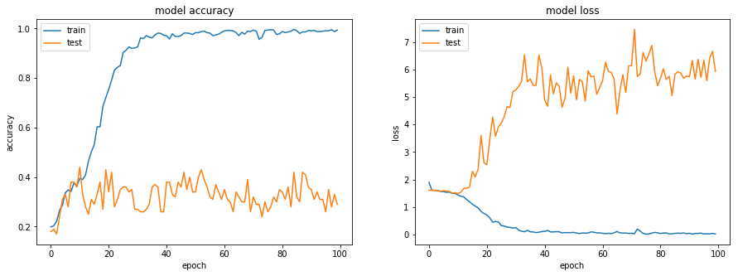

0********************************************************************************************************0

Experiments - 8

jupyter_file name: Neural_Nets_Project_Starter_Code4

**Decision/ Explanation:**

num_epochs = 25 (reduced)

Introduced Kernal Regularizer. kernel_regularizer=l2(0.01)

model.add(Dense(512, kernel_regularizer=l2(0.001)))

**Other Parameters**

Image Size = 128x128

Batch Size = 40

img_idx = np.array( range(0,30,3)) #10 images

num_epochs = 25 (reduced)

optimiser = "adam"

steps_per_epoch = int(num_train_sequences/batch_size) => 17

validation_steps = int(num_val_sequences/batch_size)  => 2

**Architecture**

model.add(Conv3D(32, (2, 3, 3), kernel_regularizer=l2(0.01), bias_regularizer=l2(0.01), padding='same',  input_shape=(imgs_from_1video, imsize[0],imsize[1],3)))

model.add(Activation('relu'))

model.add(BatchNormalization())

model.add(Conv3D(32, (2, 3, 3), kernel_regularizer=l2(0.01), bias_regularizer=l2(0.01), padding='same'))

model.add(Activation('relu'))

model.add(BatchNormalization())

model.add(MaxPooling3D(pool_size=(2, 2, 2)))

model.add(Dropout(0.25))

model.add(Conv3D(64, (2, 3, 3), kernel_regularizer=l2(0.01), bias_regularizer=l2(0.01), padding='same'))

model.add(Activation('relu'))

model.add(BatchNormalization())

model.add(Conv3D(64, (2, 3, 3), kernel_regularizer=l2(0.01), bias_regularizer=l2(0.01), padding='same'))

model.add(Activation('relu'))

model.add(BatchNormalization())

model.add(MaxPooling3D(pool_size=(2, 2, 2)))

model.add(Dropout(0.25))

model.add(Conv3D(128, (2, 3, 3), kernel_regularizer=l2(0.01), bias_regularizer=l2(0.01), padding='same'))

model.add(Activation('relu'))

model.add(BatchNormalization())

model.add(Conv3D(128, (2, 3, 3), kernel_regularizer=l2(0.01), bias_regularizer=l2(0.01), padding='same'))

model.add(Activation('relu'))

model.add(BatchNormalization())

model.add(MaxPooling3D(pool_size=(2, 2, 2)))

model.add(Dropout(0.25))

model.add(Flatten())

model.add(Dense(512, kernel_regularizer=l2(0.001)))

model.add(Activation('relu'))

model.add(BatchNormalization())

model.add(Dropout(0.5))

model.add(Dense(num_classes))

model.add(Activation('softmax'))

#write your model here

**Model Summary**

_________________________________________________________________

Layer (type) Output Shape Param #

=================================================================

conv3d_1 (Conv3D) (None, 10, 128, 128, 32) 1760

_________________________________________________________________

activation_1 (Activation) (None, 10, 128, 128, 32) 0

_________________________________________________________________

batch_normalization_1 (Batch (None, 10, 128, 128, 32) 128

_________________________________________________________________

conv3d_2 (Conv3D) (None, 10, 128, 128, 32) 18464

_________________________________________________________________

activation_2 (Activation) (None, 10, 128, 128, 32) 0

_________________________________________________________________

batch_normalization_2 (Batch (None, 10, 128, 128, 32) 128

_________________________________________________________________

max_pooling3d_1 (MaxPooling3 (None, 5, 64, 64, 32) 0

_________________________________________________________________

dropout_1 (Dropout) (None, 5, 64, 64, 32) 0

_________________________________________________________________

conv3d_3 (Conv3D) (None, 5, 64, 64, 64) 36928

_________________________________________________________________

activation_3 (Activation) (None, 5, 64, 64, 64) 0

_________________________________________________________________

batch_normalization_3 (Batch (None, 5, 64, 64, 64) 256

_________________________________________________________________

conv3d_4 (Conv3D) (None, 5, 64, 64, 64) 73792

_________________________________________________________________

activation_4 (Activation) (None, 5, 64, 64, 64) 0

_________________________________________________________________

batch_normalization_4 (Batch (None, 5, 64, 64, 64) 256

_________________________________________________________________

max_pooling3d_2 (MaxPooling3 (None, 2, 32, 32, 64) 0

_________________________________________________________________

dropout_2 (Dropout) (None, 2, 32, 32, 64) 0

_________________________________________________________________

conv3d_5 (Conv3D) (None, 2, 32, 32, 128) 147584

_________________________________________________________________

activation_5 (Activation) (None, 2, 32, 32, 128) 0

_________________________________________________________________

batch_normalization_5 (Batch (None, 2, 32, 32, 128) 512

_________________________________________________________________

conv3d_6 (Conv3D) (None, 2, 32, 32, 128) 295040

_________________________________________________________________

activation_6 (Activation) (None, 2, 32, 32, 128) 0

_________________________________________________________________

batch_normalization_6 (Batch (None, 2, 32, 32, 128) 512

_________________________________________________________________

max_pooling3d_3 (MaxPooling3 (None, 1, 16, 16, 128) 0

_________________________________________________________________

dropout_3 (Dropout) (None, 1, 16, 16, 128) 0

_________________________________________________________________

flatten_1 (Flatten) (None, 32768) 0

_________________________________________________________________

dense_1 (Dense) (None, 512) 16777728

_________________________________________________________________

activation_7 (Activation) (None, 512) 0

_________________________________________________________________

batch_normalization_7 (Batch (None, 512) 2048

_________________________________________________________________

dropout_4 (Dropout) (None, 512) 0

_________________________________________________________________

dense_2 (Dense) (None, 5) 2565

_________________________________________________________________

activation_8 (Activation) (None, 5) 0

=================================================================

Total params: 17,357,701

Trainable params: 17,355,781

Non-trainable params: 1,920

_________________________________________________________________

None

**Result**

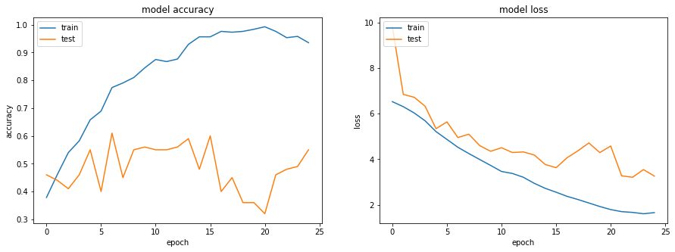

0******************************************************************************************************0

Experiments - 9

jupyter_file name: Neural_Nets_Project_Starter_Code5

**Decision/ Explanation:**

change kernel size. 3x3 => 4x4

increaes drop out. 25% => 30%

kernel_regularizer=l2(0.1), bias_regularizer=l2(0.1)

model.add(Dense(512, kernel_regularizer=l2(0.1)))

**Other Parameters**

Image Size = 128x128

Batch Size = 40

img_idx = np.array( range(0,30,3)) #10 images

num_epochs = 25 (reduced batch size)

optimiser = "adam"

steps_per_epoch = int(num_train_sequences/batch_size) => 17

validation_steps = int(num_val_sequences/batch_size)  => 2

Architecture

model.add(Conv3D(32, (2, 4, 4), padding='same', input_shape=(imgs_from_1video, imsize[0],imsize[1],3)))

model.add(Activation('relu'))

model.add(BatchNormalization())

model.add(Conv3D(32, (2, 4, 4), kernel_regularizer=l2(0.1), bias_regularizer=l2(0.1), padding='same'))

model.add(Activation('relu'))

model.add(BatchNormalization())

model.add(MaxPooling3D(pool_size=(2, 2, 2)))

model.add(Dropout(0.30))

model.add(Conv3D(64, (2, 4, 4), kernel_regularizer=l2(0.1), bias_regularizer=l2(0.1), padding='same'))

model.add(Activation('relu'))

model.add(BatchNormalization())

model.add(Conv3D(64, (2, 4, 4), kernel_regularizer=l2(0.1), bias_regularizer=l2(0.1), padding='same'))

model.add(Activation('relu'))

model.add(BatchNormalization())

model.add(MaxPooling3D(pool_size=(2, 2, 2)))

model.add(Dropout(0.30))

model.add(Conv3D(128, (2, 4, 4), kernel_regularizer=l2(0.1), bias_regularizer=l2(0.1), padding='same'))

model.add(Activation('relu'))

model.add(BatchNormalization())

model.add(Conv3D(128, (2, 4, 4), kernel_regularizer=l2(0.1), bias_regularizer=l2(0.1), padding='same'))

model.add(Activation('relu'))

model.add(BatchNormalization())

model.add(MaxPooling3D(pool_size=(2, 2, 2)))

model.add(Dropout(0.30))

model.add(Flatten())

model.add(Dense(512, kernel_regularizer=l2(0.1)))

model.add(Activation('relu'))

model.add(BatchNormalization())

model.add(Dropout(0.6))

model.add(Dense(num_classes))

model.add(Activation('softmax'))

#write your model here

Model Summary

_________________________________________________________________

Layer (type) Output Shape Param #

=================================================================

conv3d_1 (Conv3D) (None, 10, 128, 128, 32) 3104

_________________________________________________________________

activation_1 (Activation) (None, 10, 128, 128, 32) 0

_________________________________________________________________

batch_normalization_1 (Batch (None, 10, 128, 128, 32) 128

_________________________________________________________________

conv3d_2 (Conv3D) (None, 10, 128, 128, 32) 32800

_________________________________________________________________

activation_2 (Activation) (None, 10, 128, 128, 32) 0

_________________________________________________________________

batch_normalization_2 (Batch (None, 10, 128, 128, 32) 128

_________________________________________________________________

max_pooling3d_1 (MaxPooling3 (None, 5, 64, 64, 32) 0

_________________________________________________________________

dropout_1 (Dropout) (None, 5, 64, 64, 32) 0

_________________________________________________________________

conv3d_3 (Conv3D) (None, 5, 64, 64, 64) 65600

_________________________________________________________________

activation_3 (Activation) (None, 5, 64, 64, 64) 0

_________________________________________________________________

batch_normalization_3 (Batch (None, 5, 64, 64, 64) 256

_________________________________________________________________

conv3d_4 (Conv3D) (None, 5, 64, 64, 64) 131136

_________________________________________________________________

activation_4 (Activation) (None, 5, 64, 64, 64) 0

_________________________________________________________________

batch_normalization_4 (Batch (None, 5, 64, 64, 64) 256

_________________________________________________________________

max_pooling3d_2 (MaxPooling3 (None, 2, 32, 32, 64) 0

_________________________________________________________________

dropout_2 (Dropout) (None, 2, 32, 32, 64) 0

_________________________________________________________________

conv3d_5 (Conv3D) (None, 2, 32, 32, 128) 262272

_________________________________________________________________

activation_5 (Activation) (None, 2, 32, 32, 128) 0

_________________________________________________________________

batch_normalization_5 (Batch (None, 2, 32, 32, 128) 512

_________________________________________________________________

conv3d_6 (Conv3D) (None, 2, 32, 32, 128) 524416

_________________________________________________________________

activation_6 (Activation) (None, 2, 32, 32, 128) 0

_________________________________________________________________

batch_normalization_6 (Batch (None, 2, 32, 32, 128) 512

_________________________________________________________________

max_pooling3d_3 (MaxPooling3 (None, 1, 16, 16, 128) 0

_________________________________________________________________

dropout_3 (Dropout) (None, 1, 16, 16, 128) 0

_________________________________________________________________

flatten_1 (Flatten) (None, 32768) 0

_________________________________________________________________

dense_1 (Dense) (None, 512) 16777728

_________________________________________________________________

activation_7 (Activation) (None, 512) 0

_________________________________________________________________

batch_normalization_7 (Batch (None, 512) 2048

_________________________________________________________________

dropout_4 (Dropout) (None, 512) 0

_________________________________________________________________

dense_2 (Dense) (None, 5) 2565

_________________________________________________________________

activation_8 (Activation) (None, 5) 0

=================================================================

Total params: 17,803,461

Trainable params: 17,801,541

Non-trainable params: 1,920

_________________________________________________________________

None

**Results**

Training Accuracy dropped significantly and no improvement in val accuracy

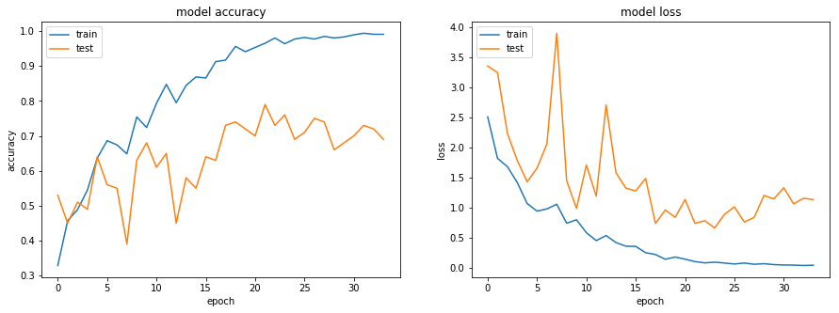

0******************************************************************************************************0

Experiments - 9

jupyter_file name: Neural_Nets_Project_Starter_Code6

**Decision/ Explanation:**

num_epochs = 60

Add kernel to first conv3d layer. kernel_regularizer=l2(0.1)

model.add(Dense(512, kernel_regularizer=l2(0.001)))

**Other Parameters from Previous Experiment**

change kernel size. 3x3 => 4x4

kernel_regularizer=l2(0.1), bias_regularizer=l2(0.1)

Image Size = 128x128

Batch Size = 40

img_idx = np.array( range(0,30,3)) #10 images

num_epochs = 25 (reduced batch size)

optimiser = "adam"

steps_per_epoch = int(num_train_sequences/batch_size) => 17

validation_steps = int(num_val_sequences/batch_size)  => 2

**Architecture**

model = Sequential()

model.add(Conv3D(32, (2, 4, 4), kernel_regularizer=l2(0.1), padding='same',

                 input_shape=(imgs_from_1video, imsize[0],imsize[1],3)))

model.add(Activation('relu'))

model.add(BatchNormalization())

model.add(Conv3D(32, (2, 4, 4), kernel_regularizer=l2(0.1), bias_regularizer=l2(0.1), padding='same'))

model.add(Activation('relu'))

model.add(BatchNormalization())

model.add(MaxPooling3D(pool_size=(2, 2, 2)))

model.add(Dropout(0.30))

model.add(Conv3D(64, (2, 4, 4), kernel_regularizer=l2(0.1), bias_regularizer=l2(0.1), padding='same'))

model.add(Activation('relu'))

model.add(BatchNormalization())

model.add(Conv3D(64, (2, 4, 4), kernel_regularizer=l2(0.1), bias_regularizer=l2(0.1), padding='same'))

model.add(Activation('relu'))

model.add(BatchNormalization())

model.add(MaxPooling3D(pool_size=(2, 2, 2)))

model.add(Dropout(0.30))

model.add(Conv3D(128, (2, 4, 4), kernel_regularizer=l2(0.1), bias_regularizer=l2(0.1), padding='same'))

model.add(Activation('relu'))

model.add(BatchNormalization())

model.add(Conv3D(128, (2, 4, 4), kernel_regularizer=l2(0.1), bias_regularizer=l2(0.1), padding='same'))

model.add(Activation('relu'))

model.add(BatchNormalization())

model.add(MaxPooling3D(pool_size=(2, 2, 2)))

model.add(Dropout(0.30))

model.add(Flatten())

model.add(Dense(512, kernel_regularizer=l2(0.001)))

model.add(Activation('relu'))

model.add(BatchNormalization())

model.add(Dropout(0.6))

model.add(Dense(num_classes))

model.add(Activation('softmax'))

#write your model here

_________________________________________________________________

Layer (type) Output Shape Param #

=================================================================

conv3d_1 (Conv3D) (None, 10, 128, 128, 32) 3104

_________________________________________________________________

activation_1 (Activation) (None, 10, 128, 128, 32) 0

_________________________________________________________________

batch_normalization_1 (Batch (None, 10, 128, 128, 32) 128

_________________________________________________________________

conv3d_2 (Conv3D) (None, 10, 128, 128, 32) 32800

_________________________________________________________________

activation_2 (Activation) (None, 10, 128, 128, 32) 0

_________________________________________________________________

batch_normalization_2 (Batch (None, 10, 128, 128, 32) 128

_________________________________________________________________

max_pooling3d_1 (MaxPooling3 (None, 5, 64, 64, 32) 0

_________________________________________________________________

dropout_1 (Dropout) (None, 5, 64, 64, 32) 0

_________________________________________________________________

conv3d_3 (Conv3D) (None, 5, 64, 64, 64) 65600

_________________________________________________________________

activation_3 (Activation) (None, 5, 64, 64, 64) 0

_________________________________________________________________

batch_normalization_3 (Batch (None, 5, 64, 64, 64) 256

_________________________________________________________________

conv3d_4 (Conv3D) (None, 5, 64, 64, 64) 131136

_________________________________________________________________

activation_4 (Activation) (None, 5, 64, 64, 64) 0

_________________________________________________________________

batch_normalization_4 (Batch (None, 5, 64, 64, 64) 256

_________________________________________________________________

max_pooling3d_2 (MaxPooling3 (None, 2, 32, 32, 64) 0

_________________________________________________________________

dropout_2 (Dropout) (None, 2, 32, 32, 64) 0

_________________________________________________________________

conv3d_5 (Conv3D) (None, 2, 32, 32, 128) 262272

_________________________________________________________________

activation_5 (Activation) (None, 2, 32, 32, 128) 0

_________________________________________________________________

batch_normalization_5 (Batch (None, 2, 32, 32, 128) 512

_________________________________________________________________

conv3d_6 (Conv3D) (None, 2, 32, 32, 128) 524416

_________________________________________________________________

activation_6 (Activation) (None, 2, 32, 32, 128) 0

_________________________________________________________________

batch_normalization_6 (Batch (None, 2, 32, 32, 128) 512

_________________________________________________________________

max_pooling3d_3 (MaxPooling3 (None, 1, 16, 16, 128) 0

_________________________________________________________________

dropout_3 (Dropout) (None, 1, 16, 16, 128) 0

_________________________________________________________________

flatten_1 (Flatten) (None, 32768) 0

_________________________________________________________________

dense_1 (Dense) (None, 512) 16777728

_________________________________________________________________

activation_7 (Activation) (None, 512) 0

_________________________________________________________________

batch_normalization_7 (Batch (None, 512) 2048

_________________________________________________________________

dropout_4 (Dropout) (None, 512) 0

_________________________________________________________________

dense_2 (Dense) (None, 5) 2565

_________________________________________________________________

activation_8 (Activation) (None, 5) 0

=================================================================

Total params: 17,803,461

Trainable params: 17,801,541

Non-trainable params: 1,920

_________________________________________________________________

None

**Results**

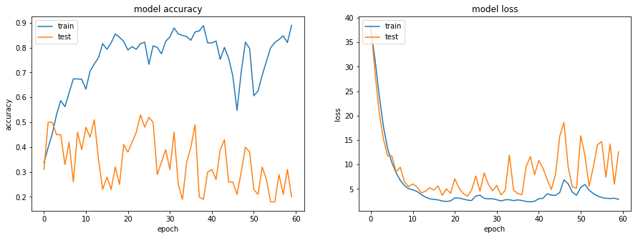

0******************************************************************************************************0

Experiments - 10

jupyter_file name: Neural_Nets_Project_Starter_Code7

**Decision/ Explanation:**

num_epochs = 25

enable saving models

**Other Parameters from Previous Experiment**

kernel size. 3x3

Image Size = 128x128

Batch Size = 40

img_idx = np.array( range(0,30,3)) #10 images

num_epochs = 25 (reduced batch size)

optimiser = "adam"

steps_per_epoch = int(num_train_sequences/batch_size) => 17

validation_steps = int(num_val_sequences/batch_size)  => 2

**Architecture**

model.add(Conv3D(32, (2, 3, 3), padding='same',

input_shape=(imgs_from_1video, imsize[0],imsize[1],3)))

model.add(Activation('relu'))

model.add(BatchNormalization())

model.add(Conv3D(32, (2, 3, 3), padding='same'))

model.add(Activation('relu'))

model.add(BatchNormalization())

model.add(MaxPooling3D(pool_size=(2, 2, 2)))

model.add(Dropout(0.25))

model.add(Conv3D(64, (2, 3, 3), padding='same'))

model.add(Activation('relu'))

model.add(BatchNormalization())

model.add(Conv3D(64, (2, 3, 3), padding='same'))

model.add(Activation('relu'))

model.add(BatchNormalization())

model.add(MaxPooling3D(pool_size=(2, 2, 2)))

model.add(Dropout(0.25))

model.add(Conv3D(128, (2, 3, 3), padding='same'))

model.add(Activation('relu'))

model.add(BatchNormalization())

model.add(Conv3D(128, (2, 3, 3), padding='same'))

model.add(Activation('relu'))

model.add(BatchNormalization())

model.add(MaxPooling3D(pool_size=(2, 2, 2)))

model.add(Dropout(0.25))

model.add(Flatten())

model.add(Dense(512))

model.add(Activation('relu'))

model.add(BatchNormalization())

model.add(Dropout(0.5))

model.add(Dense(num_classes))

model.add(Activation('softmax'))

#write your model here

**Results**

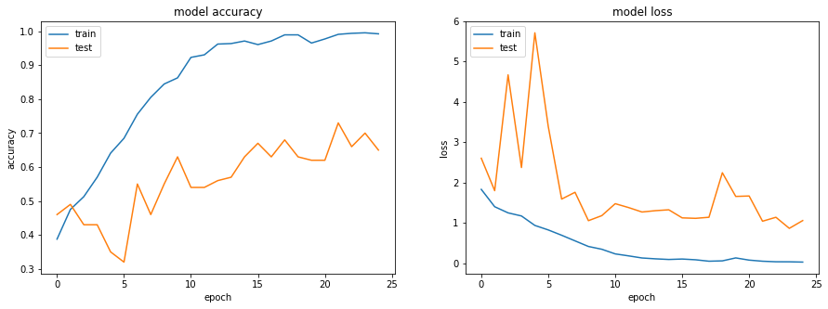

**CNN+RNN**

Experiments – 11 : CNN+RNN

jupyter_file name: Neural_Nets_Project_Starter_Code8

**Decision/ Explanation:**

num_epochs = 25

disable saving models

**Other Parameters from Previous Experiment**

kernel size. 3x3

Image Size = 128x128

Batch Size = 40

img_idx = np.array( range(0,30,3)) #10 images

num_epochs = 25 (reduced batch size)

optimiser = "adam"

steps_per_epoch = int(num_train_sequences/batch_size) => 17

validation_steps = int(num_val_sequences/batch_size)  => 2

**Architecture**

#### Set1

model.add(TimeDistributed(Conv2D(32, (5, 5), strides=(2, 2), activation='relu',

padding='same'), input_shape=(imgs_from_1video, imsize[0],imsize[1], 3)))

model.add(TimeDistributed(Conv2D(32, (3,3), kernel_initializer="he_normal", activation='relu')))

#model.add(BatchNormalization())

model.add(TimeDistributed( MaxPooling2D((2, 2), strides=(2, 2))) )

model.add(Dropout(0.25))

#### Set2

model.add(TimeDistributed(Conv2D(64, (3,3), padding='same', activation='relu')))

model.add(TimeDistributed(Conv2D(64, (3,3), padding='same', activation='relu')))

#model.add(BatchNormalization())

model.add(TimeDistributed( MaxPooling2D(pool_size=(2, 2))) )

model.add(Dropout(0.25))

#### Set3

model.add(TimeDistributed(Conv2D(124, (3,3), padding='same', activation='relu')))

model.add(TimeDistributed(Conv2D(124, (3,3), padding='same', activation='relu')))

#model.add(BatchNormalization())

model.add(TimeDistributed( MaxPooling2D(pool_size=(2, 2))) )

model.add(Dropout(0.25))

#### Set4

model.add(TimeDistributed(Conv2D(256, (3,3), padding='same', activation='relu')))

model.add(TimeDistributed(Conv2D(256, (3,3), padding='same', activation='relu')))

#model.add(BatchNormalization())

model.add(TimeDistributed( MaxPooling2D(pool_size=(2, 2))) )

model.add(Dropout(0.25))

#### Set3

model.add(TimeDistributed(Conv2D(512, (3,3), padding='same', activation='relu')))

model.add(TimeDistributed(Conv2D(512, (3,3), padding='same', activation='relu')))

#model.add(BatchNormalization())

model.add(TimeDistributed( MaxPooling2D(pool_size=(2, 2))))

model.add(Dropout(0.25))

model.add(TimeDistributed(Flatten()))

model.add(Dropout(0.5))

model.add(GRU(256, return_sequences=False, dropout=0.5))

model.add(Dense(num_classes, activation='softmax'))

model.summary()

Layer (type) Output Shape Param #

=================================================================

time_distributed_10 (TimeDis (None, 10, 64, 64, 32) 2432

_________________________________________________________________

time_distributed_11 (TimeDis (None, 10, 62, 62, 32) 9248

_________________________________________________________________

time_distributed_12 (TimeDis (None, 10, 31, 31, 32) 0

_________________________________________________________________

dropout_4 (Dropout) (None, 10, 31, 31, 32) 0

_________________________________________________________________

time_distributed_13 (TimeDis (None, 10, 31, 31, 64) 18496

_________________________________________________________________

time_distributed_14 (TimeDis (None, 10, 31, 31, 64) 36928

_________________________________________________________________

time_distributed_15 (TimeDis (None, 10, 15, 15, 64) 0

_________________________________________________________________

dropout_5 (Dropout) (None, 10, 15, 15, 64) 0

_________________________________________________________________

time_distributed_16 (TimeDis (None, 10, 15, 15, 124) 71548

_________________________________________________________________

time_distributed_17 (TimeDis (None, 10, 15, 15, 124) 138508

_________________________________________________________________

time_distributed_18 (TimeDis (None, 10, 7, 7, 124) 0

_________________________________________________________________

dropout_6 (Dropout) (None, 10, 7, 7, 124) 0

_________________________________________________________________

time_distributed_19 (TimeDis (None, 10, 7, 7, 256) 285952

_________________________________________________________________

time_distributed_20 (TimeDis (None, 10, 7, 7, 256) 590080

_________________________________________________________________

time_distributed_21 (TimeDis (None, 10, 3, 3, 256) 0

_________________________________________________________________

dropout_7 (Dropout) (None, 10, 3, 3, 256) 0

_________________________________________________________________

time_distributed_22 (TimeDis (None, 10, 3, 3, 512) 1180160

_________________________________________________________________

time_distributed_23 (TimeDis (None, 10, 3, 3, 512) 2359808

_________________________________________________________________

time_distributed_24 (TimeDis (None, 10, 1, 1, 512) 0

_________________________________________________________________

dropout_8 (Dropout) (None, 10, 1, 1, 512) 0

_________________________________________________________________

time_distributed_25 (TimeDis (None, 10, 512) 0

_________________________________________________________________

dropout_9 (Dropout) (None, 10, 512) 0

_________________________________________________________________

gru_1 (GRU) (None, 256) 590592

_________________________________________________________________

dense_1 (Dense) (None, 5) 1285

=================================================================

Total params: 5,285,037

Trainable params: 5,285,037

Non-trainable params: 0

Results

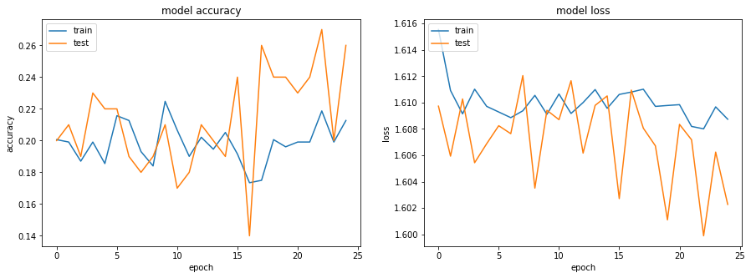

0******************************************************************************************************0

Experiments – 11 : CNN+RNN

jupyter_file name: Neural_Nets_Project_Starter_Code9

**Decision/ Explanation:**

num_epochs = 50

remove drop after each layer

**Other Parameters from Previous Experiment**

kernel size. 3x3

Image Size = 128x128

Batch Size = 40

img_idx = np.array( range(0,30,3)) #10 images

num_epochs = 25 (reduced batch size)

optimiser = "adam"

steps_per_epoch = int(num_train_sequences/batch_size) => 17

validation_steps = int(num_val_sequences/batch_size)  => 2

**Architecture**

#### Set1

model.add(TimeDistributed(Conv2D(32, (5, 5), strides=(2, 2), activation='relu',

padding='same'), input_shape=(imgs_from_1video, imsize[0],imsize[1], 3)))

model.add(TimeDistributed(Conv2D(32, (3,3), kernel_initializer="he_normal", activation='relu')))

#model.add(BatchNormalization())

model.add(TimeDistributed( MaxPooling2D((2, 2), strides=(2, 2))) )

#model.add(Dropout(0.25))

#### Set2

model.add(TimeDistributed(Conv2D(64, (3,3), padding='same', activation='relu')))

model.add(TimeDistributed(Conv2D(64, (3,3), padding='same', activation='relu')))

#model.add(BatchNormalization())

model.add(TimeDistributed( MaxPooling2D(pool_size=(2, 2))) )

#model.add(Dropout(0.25))

#### Set3

model.add(TimeDistributed(Conv2D(124, (3,3), padding='same', activation='relu')))

model.add(TimeDistributed(Conv2D(124, (3,3), padding='same', activation='relu')))

#model.add(BatchNormalization())

model.add(TimeDistributed( MaxPooling2D(pool_size=(2, 2))) )

#model.add(Dropout(0.25))

#### Set4

model.add(TimeDistributed(Conv2D(256, (3,3), padding='same', activation='relu')))

model.add(TimeDistributed(Conv2D(256, (3,3), padding='same', activation='relu')))

#model.add(BatchNormalization())

model.add(TimeDistributed( MaxPooling2D(pool_size=(2, 2))) )

model.add(Dropout(0.25))

#### Set3

model.add(TimeDistributed(Conv2D(512, (3,3), padding='same', activation='relu')))

model.add(TimeDistributed(Conv2D(512, (3,3), padding='same', activation='relu')))

#model.add(BatchNormalization())

model.add(TimeDistributed( MaxPooling2D(pool_size=(2, 2))))

#model.add(Dropout(0.25))

model.add(TimeDistributed(Flatten()))

model.add(Dropout(0.5))

model.add(GRU(256, return_sequences=False, dropout=0.5))

model.add(Dense(num_classes, activation='softmax'))

_________________________________________________________________

Layer (type) Output Shape Param #

=================================================================

time_distributed_1 (TimeDist (None, 10, 64, 64, 32) 2432

_________________________________________________________________

time_distributed_2 (TimeDist (None, 10, 62, 62, 32) 9248

_________________________________________________________________

time_distributed_3 (TimeDist (None, 10, 31, 31, 32) 0

_________________________________________________________________

time_distributed_4 (TimeDist (None, 10, 31, 31, 64) 18496

_________________________________________________________________

time_distributed_5 (TimeDist (None, 10, 31, 31, 64) 36928

_________________________________________________________________

time_distributed_6 (TimeDist (None, 10, 15, 15, 64) 0

_________________________________________________________________

time_distributed_7 (TimeDist (None, 10, 15, 15, 124) 71548

_________________________________________________________________

time_distributed_8 (TimeDist (None, 10, 15, 15, 124) 138508

_________________________________________________________________

time_distributed_9 (TimeDist (None, 10, 7, 7, 124) 0

_________________________________________________________________

time_distributed_10 (TimeDis (None, 10, 7, 7, 256) 285952

_________________________________________________________________

time_distributed_11 (TimeDis (None, 10, 7, 7, 256) 590080

_________________________________________________________________

time_distributed_12 (TimeDis (None, 10, 3, 3, 256) 0

_________________________________________________________________

dropout_1 (Dropout) (None, 10, 3, 3, 256) 0

_________________________________________________________________

time_distributed_13 (TimeDis (None, 10, 3, 3, 512) 1180160

_________________________________________________________________

time_distributed_14 (TimeDis (None, 10, 3, 3, 512) 2359808

_________________________________________________________________

time_distributed_15 (TimeDis (None, 10, 1, 1, 512) 0

_________________________________________________________________

time_distributed_16 (TimeDis (None, 10, 512) 0

_________________________________________________________________

dropout_2 (Dropout) (None, 10, 512) 0

_________________________________________________________________

gru_1 (GRU) (None, 256) 590592

_________________________________________________________________

dense_1 (Dense) (None, 5) 1285

=================================================================

Total params: 5,285,037

Trainable params: 5,285,037

Non-trainable params: 0

_________________________________________________________________

None

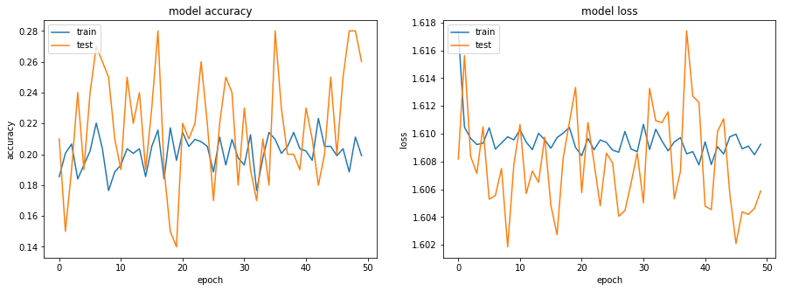

Experiments – 12 : CNN+RNN

jupyter_file name: Neural_Nets_Project_Starter_Code10

**Decision/ Explanation:**

Batch size=100

add batch normalization

**Other Parameters from Previous Experiment**

kernel size. 3x3

Image Size = 128x128

Batch Size = 40

num_epochs = 50

img_idx = np.array( range(0,30,3)) #10 images

num_epochs = 25 (reduced batch size)

optimiser = "adam"

steps_per_epoch = int(num_train_sequences/batch_size) => 17

validation_steps = int(num_val_sequences/batch_size)  => 2

#### Set1

model.add(TimeDistributed(Conv2D(32, (5, 5), strides=(2, 2), activation='relu',

padding='same'), input_shape=(imgs_from_1video, imsize[0],imsize[1], 3)))

model.add(TimeDistributed(Conv2D(32, (3,3), kernel_initializer="he_normal", activation='relu')))

model.add(BatchNormalization())

model.add(TimeDistributed( MaxPooling2D((2, 2), strides=(2, 2))) )

#model.add(Dropout(0.25))

#### Set2

model.add(TimeDistributed(Conv2D(64, (3,3), padding='same', activation='relu')))

model.add(TimeDistributed(Conv2D(64, (3,3), padding='same', activation='relu')))

model.add(BatchNormalization())

model.add(TimeDistributed( MaxPooling2D(pool_size=(2, 2))) )

#model.add(Dropout(0.25))

#### Set3

model.add(TimeDistributed(Conv2D(124, (3,3), padding='same', activation='relu')))

model.add(TimeDistributed(Conv2D(124, (3,3), padding='same', activation='relu')))

model.add(BatchNormalization())

model.add(TimeDistributed( MaxPooling2D(pool_size=(2, 2))) )

#model.add(Dropout(0.25))

#### Set4

model.add(TimeDistributed(Conv2D(256, (3,3), padding='same', activation='relu')))

model.add(TimeDistributed(Conv2D(256, (3,3), padding='same', activation='relu')))

model.add(BatchNormalization())

model.add(TimeDistributed( MaxPooling2D(pool_size=(2, 2))) )

model.add(Dropout(0.25))

#### Set3

model.add(TimeDistributed(Conv2D(512, (3,3), padding='same', activation='relu')))

model.add(TimeDistributed(Conv2D(512, (3,3), padding='same', activation='relu')))

model.add(BatchNormalization())

model.add(TimeDistributed( MaxPooling2D(pool_size=(2, 2))))

#model.add(Dropout(0.25))

model.add(TimeDistributed(Flatten()))

model.add(Dropout(0.5))

model.add(GRU(256, return_sequences=False, dropout=0.5))

model.add(Dense(num_classes, activation='softmax'))

#write your model here

_________________________________________________________________

Layer (type) Output Shape Param #

=================================================================

time_distributed_1 (TimeDist (None, 10, 64, 64, 32) 2432

_________________________________________________________________

time_distributed_2 (TimeDist (None, 10, 62, 62, 32) 9248

_________________________________________________________________

batch_normalization_1 (Batch (None, 10, 62, 62, 32) 128

_________________________________________________________________

time_distributed_3 (TimeDist (None, 10, 31, 31, 32) 0

_________________________________________________________________

time_distributed_4 (TimeDist (None, 10, 31, 31, 64) 18496

_________________________________________________________________

time_distributed_5 (TimeDist (None, 10, 31, 31, 64) 36928

_________________________________________________________________

batch_normalization_2 (Batch (None, 10, 31, 31, 64) 256

_________________________________________________________________

time_distributed_6 (TimeDist (None, 10, 15, 15, 64) 0

_________________________________________________________________

time_distributed_7 (TimeDist (None, 10, 15, 15, 124) 71548

_________________________________________________________________

time_distributed_8 (TimeDist (None, 10, 15, 15, 124) 138508

_________________________________________________________________

batch_normalization_3 (Batch (None, 10, 15, 15, 124) 496

_________________________________________________________________

time_distributed_9 (TimeDist (None, 10, 7, 7, 124) 0

_________________________________________________________________

time_distributed_10 (TimeDis (None, 10, 7, 7, 256) 285952

_________________________________________________________________

time_distributed_11 (TimeDis (None, 10, 7, 7, 256) 590080

_________________________________________________________________

batch_normalization_4 (Batch (None, 10, 7, 7, 256) 1024

_________________________________________________________________

time_distributed_12 (TimeDis (None, 10, 3, 3, 256) 0

_________________________________________________________________

dropout_1 (Dropout) (None, 10, 3, 3, 256) 0

_________________________________________________________________

time_distributed_13 (TimeDis (None, 10, 3, 3, 512) 1180160

_________________________________________________________________

time_distributed_14 (TimeDis (None, 10, 3, 3, 512) 2359808

_________________________________________________________________

batch_normalization_5 (Batch (None, 10, 3, 3, 512) 2048

_________________________________________________________________

time_distributed_15 (TimeDis (None, 10, 1, 1, 512) 0

_________________________________________________________________

time_distributed_16 (TimeDis (None, 10, 512) 0

_________________________________________________________________

dropout_2 (Dropout) (None, 10, 512) 0

_________________________________________________________________

gru_1 (GRU) (None, 256) 590592

_________________________________________________________________

dense_1 (Dense) (None, 5) 1285

=================================================================

Total params: 5,288,989

Trainable params: 5,287,013

Non-trainable params: 1,976

_________________________________________________________________

None

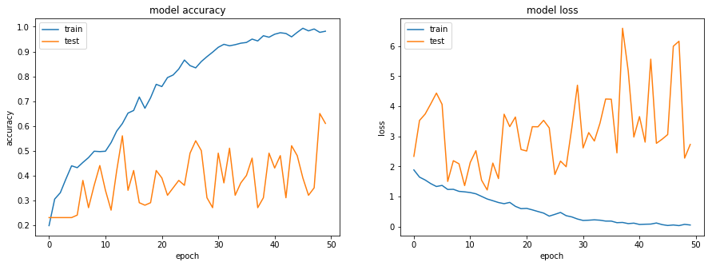

Experiments – 13 : CNN+RNN

jupyter_file name: Neural_Nets_Project_Starter_Code11

**Decision/ Explanation:**

Batch size=100

num_epochs = 100

Add dropout

Change kernel size for first layer Conv2D(32, (3, 3) (earlier 5,5)

**Other Parameters from Previous Experiment**

kernel size. 3x3

Image Size = 128x128

Batch Size = 40

img_idx = np.array( range(0,30,3)) #10 images

num_epochs = 25 (reduced batch size)

optimiser = "adam"

steps_per_epoch = int(num_train_sequences/batch_size) => 17

validation_steps = int(num_val_sequences/batch_size)  => 2

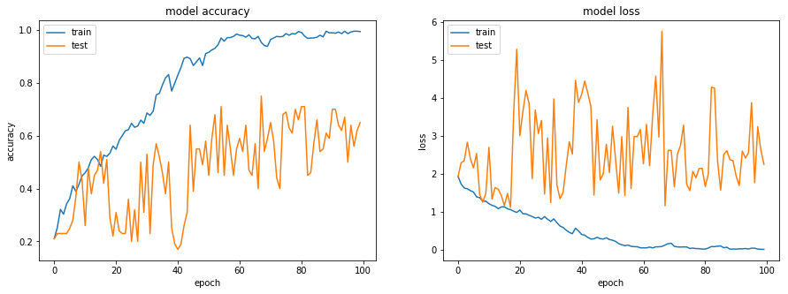

Experiments – 14 : CNN+RNN

jupyter_file name: Neural_Nets_Project_Starter_Code12

**Decision/ Explanation:**

* optimiser = Adam(lr=0.0001) #write your optimizer

**Other Parameters from Previous Experiment**

* kernel size. 3x3
* Image Size = 128x128
* Batch size=100
* num_epochs = 100
* img_idx = np.array( range(0,30,3)) #10 images
* steps_per_epoch = int(num_train_sequences/batch_size) => 17
* validation_steps = int(num_val_sequences/batch_size)  => 2

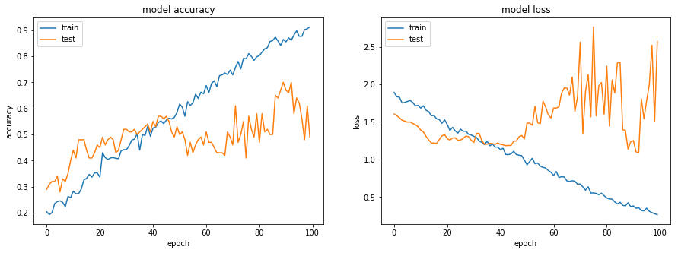

Experiments – 13 : CNN+RNN

jupyter_file name: Neural_Nets_Project_Starter_Code13

**Decision/ Explanation:**

* kernel size changed = (4,4) earlier (3,3)

**Other Parameters from Previous Experiment**

* kernel size. 4x4
* Image Size = 128x128
* Batch size=100
* num_epochs = 100
* img_idx = np.array( range(0,30,3)) #10 images
* steps_per_epoch = int(num_train_sequences/batch_size) => 17
* validation_steps = int(num_val_sequences/batch_size)  => 2

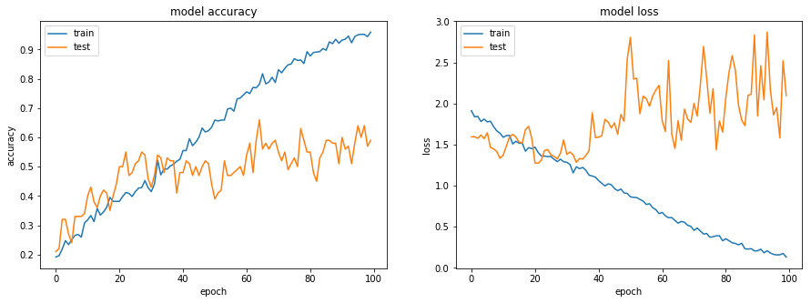

Experiments – 14 : CNN+RNN

jupyter_file name: Neural_Nets_Project_Starter_Code14

**Decision/ Explanation:**

* kernel size changed = (5,5) earlier (4,4)
* optimiser = Adam(lr=0.0005)
* Num_epochs = 60

**Other Parameters from Previous Experiment**

* kernel size. 4x4
* Image Size = 128x128
* Batch size=100
* img_idx = np.array( range(0,30,3)) #10 images
* steps_per_epoch = int(num_train_sequences/batch_size) => 17

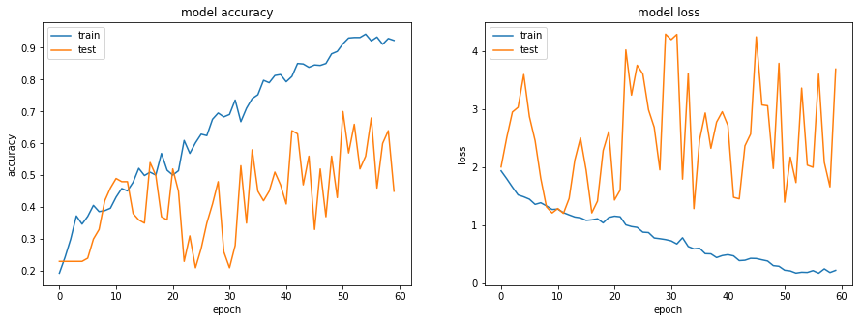

Experiments – 15 : CNN+RNN

jupyter_file name: Neural_Nets_Project_Starter_Code15

**Decision/ Explanation:**

* kernel size changed = (3,3)
* optimiser = Adam(lr=0.0005)
* Num_epochs = 60
* Only one layer (all removed)
* Dropout .80

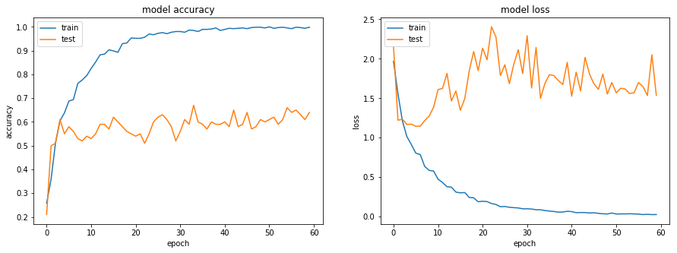

Experiments – 16 : CNN+RNN

jupyter_file name: Neural_Nets_Project_Starter_Code16

**Decision/ Explanation:**

* kernel size changed = (5,5) earlier (4,4)
* optimiser = Adam(lr=0.0005)
* Num_epochs = 25
* GRU 128
* Dropout .80

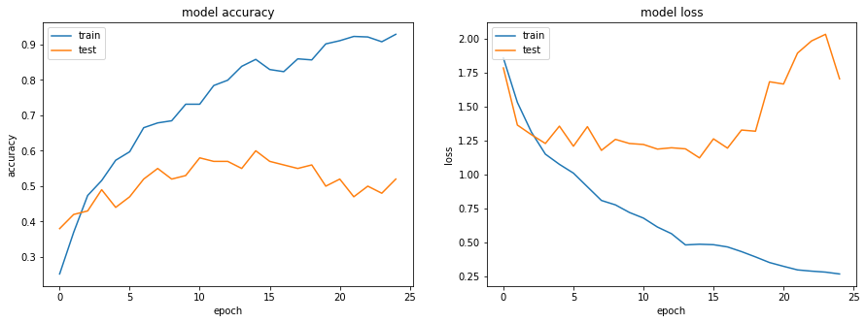

Experiments – 17 : CNN+RNN

jupyter_file name: Neural_Nets_Project_Starter_Code16 (same as before)

**Decision/ Explanation:**

* kernel size changed = (5,5) earlier (4,4)
* optimiser = Adam(lr=0.0005)
* Num_epochs = 25
* GRU 64
* Dropout .80

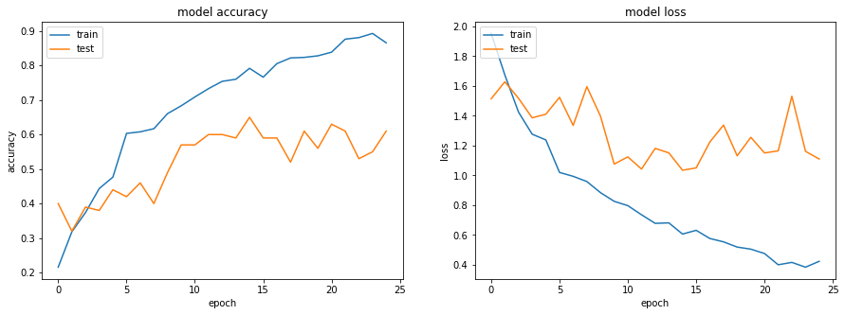

Experiments – 18 : CNN+RNN

jupyter_file name: Neural_Nets_Project_Starter_Code16 (same as before)

**Decision/ Explanation:**

* kernel size changed = (5,5) earlier (4,4)
* optimiser = Adam(lr=0.0005)
* Num_epochs = 60
* GRU 32
* Dropout .80

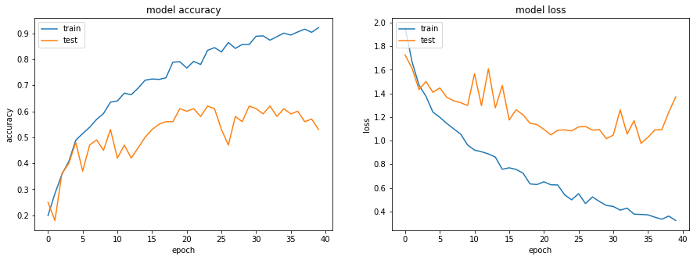

Experiments – 19 : CNN+RNN

jupyter_file name: Neural_Nets_Project_Starter_Code16 (same as before)

**Decision/ Explanation:**

* Only one CONV2D layer (all other removed).
* Conv2D(90)

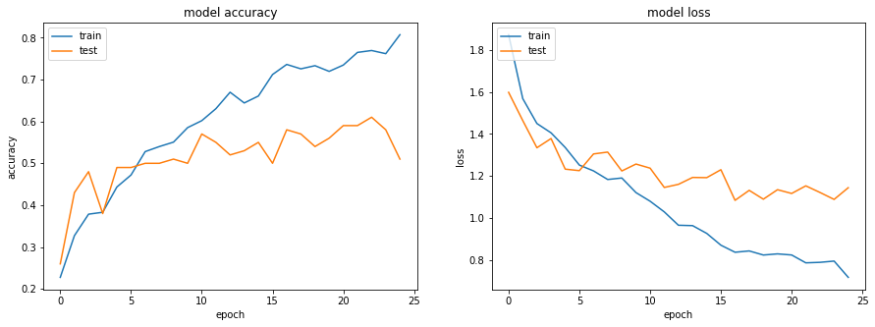

Experiments – 20 : CNN+RNN

jupyter_file name: Neural_Nets_Project_Starter_Code16 (same as before)

**Decision/ Explanation:**

* drop from GRU layer neurons. model.add(GRU(16, return_sequences=False))

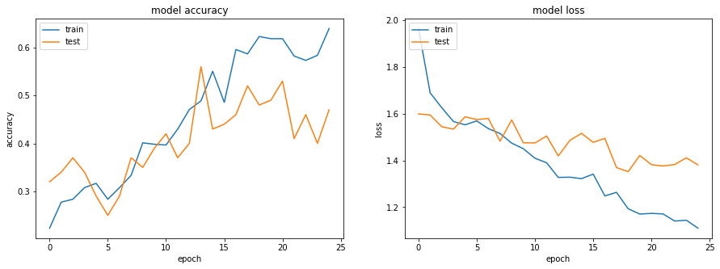

Experiments – 21 : CNN+RNN

jupyter_file name: Neural_Nets_Project_Starter_Code16 (same as before)

**Decision/ Explanation:**

* drop from GRU layer neurons. model.add(GRU(64, return_sequences=False))

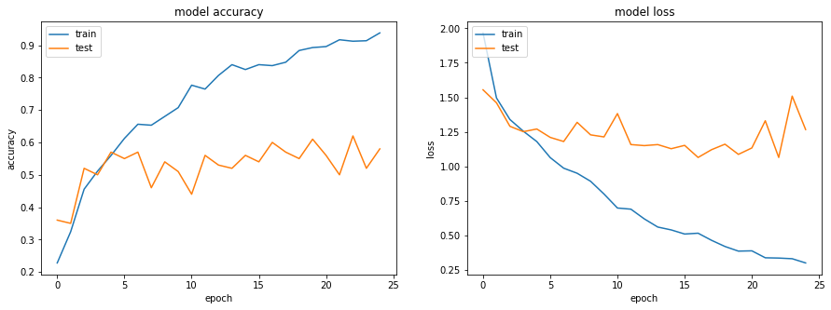

Experiments – 22 : CNN+RNN

jupyter_file name: Neural_Nets_Project_Starter_Code16 (same as before)

**Decision/ Explanation:**

* Conv2D(45, (3,3)

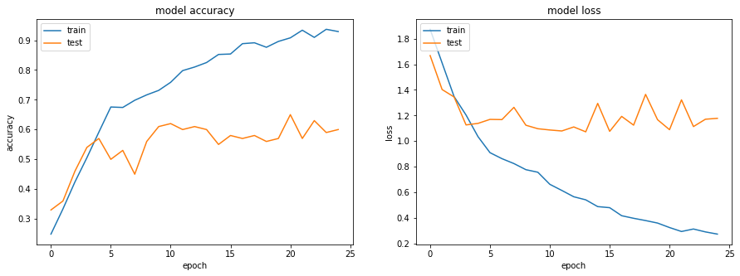

Experiments – 23 : CNN+RNN

jupyter_file name: Neural_Nets_Project_Starter_Code16 (same as before)

**Decision/ Explanation:**

* Conv2D(15, (3,3)

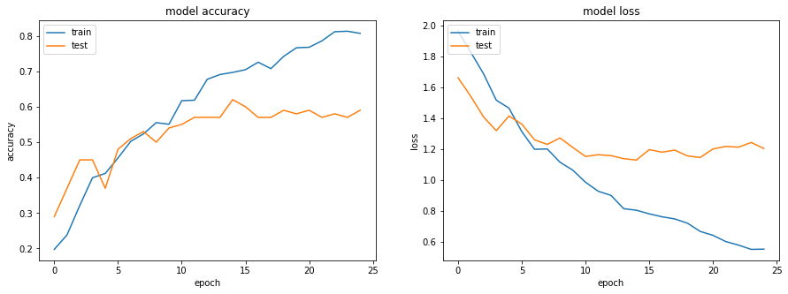

Experiments – 24 : CNN+RNN

jupyter_file name: Neural_Nets_Project_Starter_Code16 (same as before)

**Decision/ Explanation:**

* Conv2D(20, (3,3)
* GRU 128

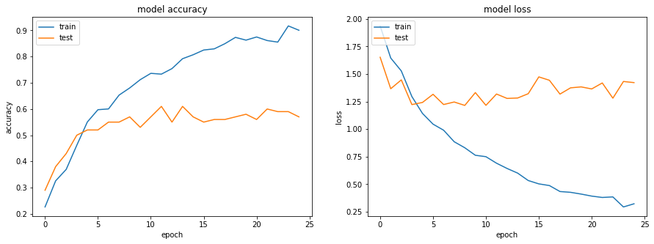

Experiments – 25 : CNN+RNN

jupyter_file name: Neural_Nets_Project_Starter_Code16 (same as before)

**Decision/ Explanation:**

* kernel_regularizer=l2(0.1)

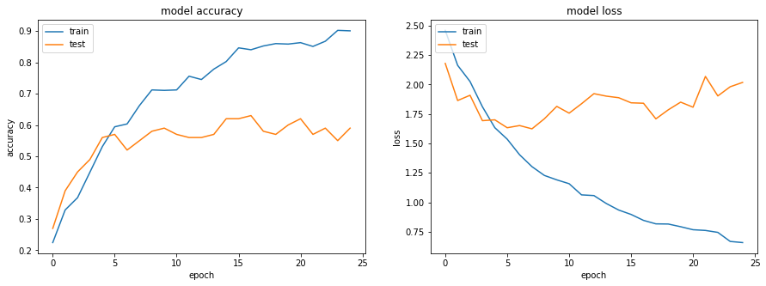

Experiments – 26 : CNN+RNN

jupyter_file name: Neural_Nets_Project_Starter_Code16 (same as before)

**Decision/ Explanation:**

* kernel_regularizer=l2(0.3)

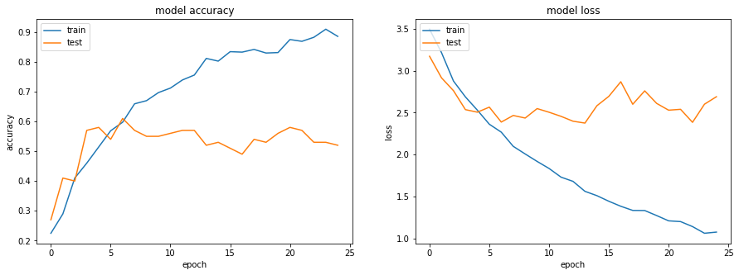

Experiments – 27 : CNN+RNN

jupyter_file name: Neural_Nets_Project_Starter_Code16 (same as before)

**Decision/ Explanation:**

* kernel_regularizer=l2(0.7)
* model.add(GRU(128, return_sequences=False)) (dropout removed)

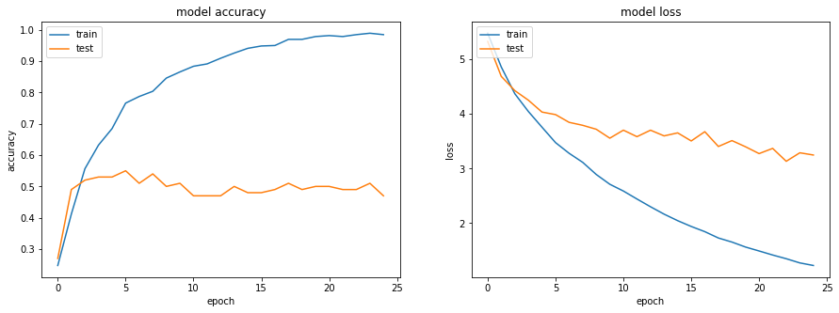

Experiments – 28 : CNN+RNN

jupyter_file name: Neural_Nets_Project_Starter_Code16 (same as before)

**Decision/ Explanation:**

* kernel_regularizer=l2(0.001)
* model.add(GRU(128, return_sequences=False)) (dropout removed)

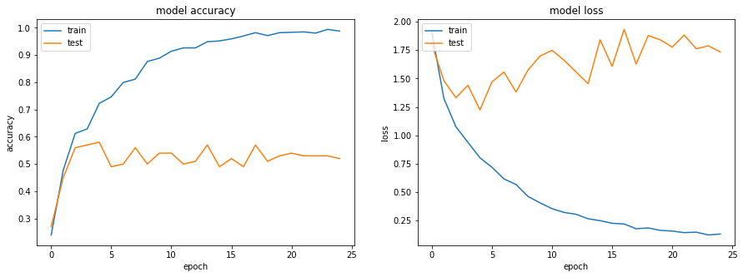

Experiments – 29 : CNN+RNN

jupyter_file name: Neural_Nets_Project_Starter_Code16 (same as before)

**Decision/ Explanation:**

* Removed regularization
* Kept three layers each of 32 neuron and kernel 3x3
* model.add(Dropout(0.5))
* GRU(64)

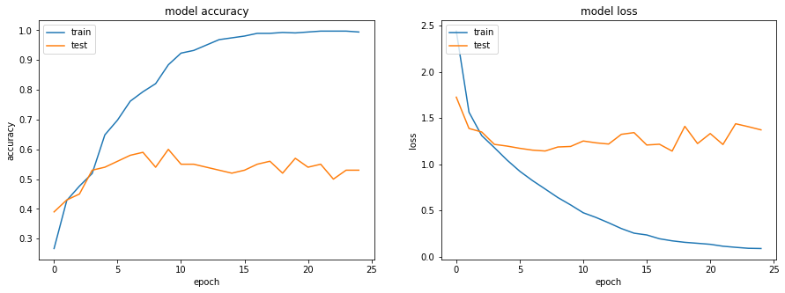

Experiments – 30 : CNN+RNN

jupyter_file name: Neural_Nets_Project_Starter_Code16 (same as before)

**Decision/ Explanation:**

* Removed regularization
* Kept three layers each of 32 neuron and kernel 3x3
* model.add(Dropout(0.5))
* GRU(64)

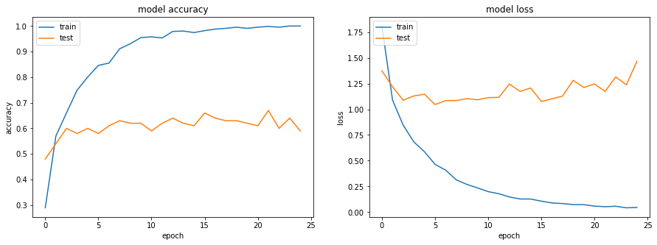

Resetting the Entire Architecture.

**Accuracy not improving. Changing Strategy and recreating architecture.**

Experiments – 31 : CNN+RNN

Jupyter_file name: Neural_Nets_Project_Starter_Code17

**Decision/ Explanation:**

* Epoch 60
* Conv2D(64, (3,3), strides=(2, 2), activation='relu', padding='same', kernel_initializer="he_normal")
* model.add(BatchNormalization())
* model.add(TimeDistributed( MaxPooling2D((3, 3), strides=(2, 2))) )
* model.add(TimeDistributed(Flatten()))
* model.add(GRU(32, return_sequences=False))

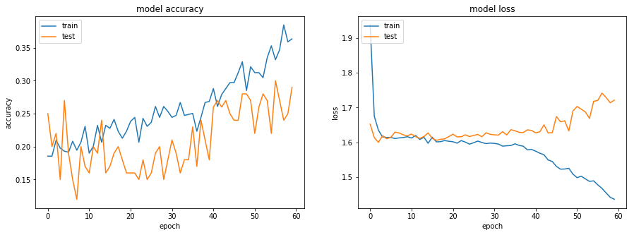

Experiments – 32 : CNN+RNN

jupyter_file name: Neural_Nets_Project_Starter_Code17 (same as before)

**Decision/ Explanation:**

* Add one more Conv2D Layer
* Increase epoch to 70

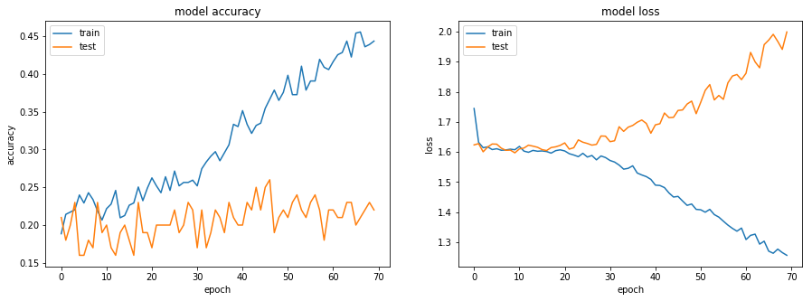

Experiments – 33 : CNN+RNN

jupyter_file name: Neural_Nets_Project_Starter_Code17 (same as before)

**Decision/ Explanation:**

* Because there is huge difference between Train and Val accuracy so adding dropout & normalization.
* At the end of conv2d (3rd layer)
  + model.add(BatchNormalization())
  + model.add(Dropout(0.50))
* Because ever after 70 epochs accuracy is very less, so Add one more Conv2D Layer (now 3 conv2d layers)

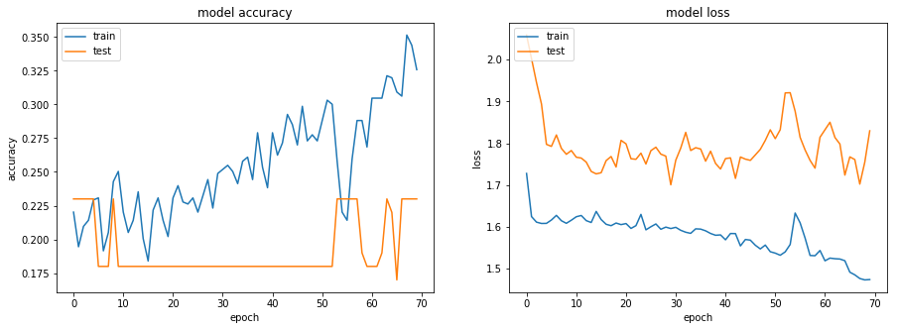

Experiments – 34 : CNN+RNN

**Jupyter_file name:** Neural_Nets_Project_Starter_Code17 (same as before)

**Decision/ Explanation:**

* Because even basic learning is not happening so
  + Remove BatchNormalization
  + Remove Dropout
* Because model is learning slow. Even after 70 iteration no much gain, so
  + optimiser = Adam(lr=0.1) earlier .001
  + LR = ReduceLROnPlateau(monitor='val_loss', factor=0.1, patience=10, verbose=0, mode='auto', min_delta=0.001, cooldown=0, min_lr=0)

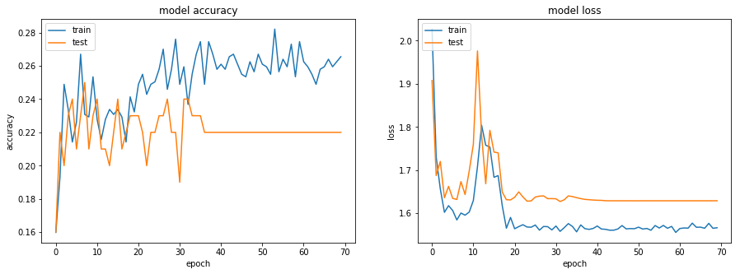

Experiments – 35 : CNN+RNN

**Jupyter_file name:** Neural_Nets_Project_Starter_Code17 (same as before)

**Decision/ Explanation:**

* Because accuracy dropped so
  + Resetting lr to .001
  + Changing optimizer to SGD (earlier Adam)

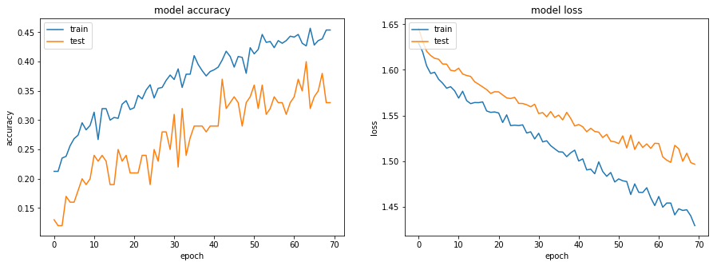

Experiments – 36 : CNN+RNN

**Jupyter_file name:** Neural_Nets_Project_Starter_Code17 (same as before)

**Decision/ Explanation:**

* Training and Val accuracy continuous and simultaneously improving. So, increasing number of epoch to 100.
* Changing number of neurons on each Conv2D layer to 32. Earlier 64.

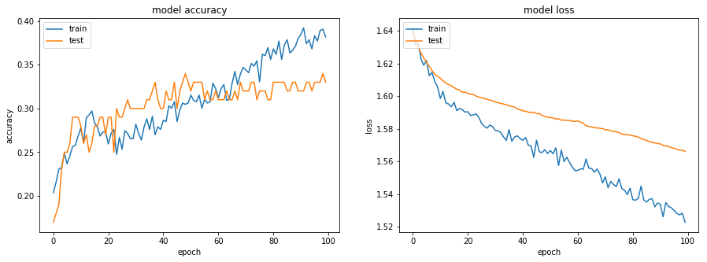

Experiments – 37 : CNN+RNN

**Jupyter_file name:** Neural_Nets_Project_Starter_Code17 (same as before)

**Decision/ Explanation:**

* Conv2D (64) + Conv2D (64)+ MaxPool2D + Conv2D(128) + Conv2D(128) + MaxPool2D

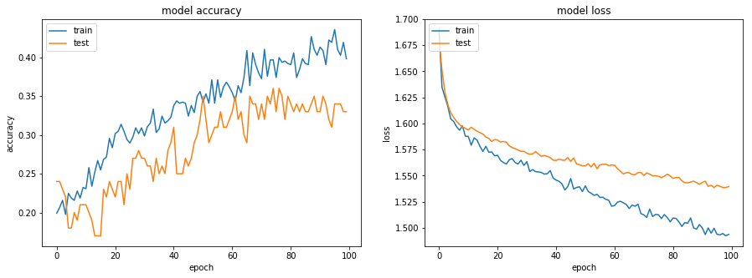

**Accuracy not improving. Changing Strategy and recreating architecture.**

Experiments – 38 : CNN+RNN

model.add(TimeDistributed(Conv2D(32, (3,3), strides=(2, 2), activation='relu',

padding='same'), input_shape=(imgs_from_1video, imsize[0],imsize[1], 3)))

#model.add(Dropout(0.25))

model.add(BatchNormalization())

model.add(TimeDistributed(Conv2D(32, (3,3), kernel_initializer="he_normal", activation='relu')))

#model.add(Dropout(0.25))

model.add(BatchNormalization())

model.add(TimeDistributed(Conv2D(32, (3,3), kernel_initializer="he_normal", activation='relu')))

model.add(Dropout(0.25))

model.add(BatchNormalization())

model.add(TimeDistributed( MaxPooling2D((3, 3), strides=(2, 2))) )

model.add(BatchNormalization())

model.add(TimeDistributed(Flatten()))

model.add(Dropout(0.5))

model.add(GRU(64, return_sequences=False))

model.add(Dense(num_classes, activation='softmax'))

######################################################################

Epoch =50

Conv2D(32(3,3)) + BatchNormalization +

Conv2D(32(3,3)) + BatchNormalization +

Conv2D(32(3,3)) + BatchNormalization +

MaxPooling2D((3, 3) strides=(2, 2) + BatchNormalization +

Flatten + dropout(.5) + GRU(64)

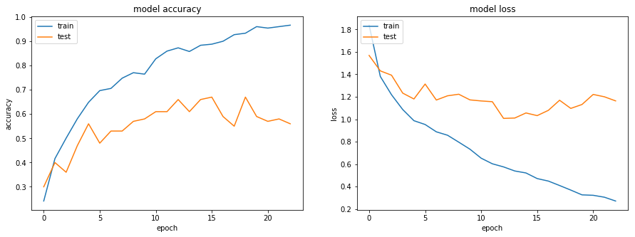

Experiments – 39 : CNN+RNN

Conv2D(32(3,3)) + dropout(.25) + BatchNormalization +

Conv2D(32(3,3)) + dropout(.25) + BatchNormalization +

Conv2D(32(3,3)) + dropout(.25) + BatchNormalization +

MaxPooling2D((3, 3) strides=(2, 2) + BatchNormalization +

Flatten + dropout(.5) + GRU(64)

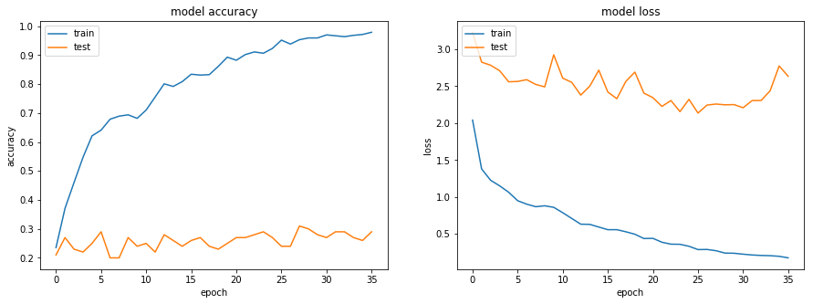

Experiments – 40 : CNN+RNN

Conv2D(32(3,3)) + BatchNormalization +

Conv2D(32(3,3)) + BatchNormalization +

Conv2D(32(3,3)) + dropout(.25) + BatchNormalization +

MaxPooling2D((3, 3) strides=(2, 2) + BatchNormalization +

Flatten + dropout(.5) + GRU(64)

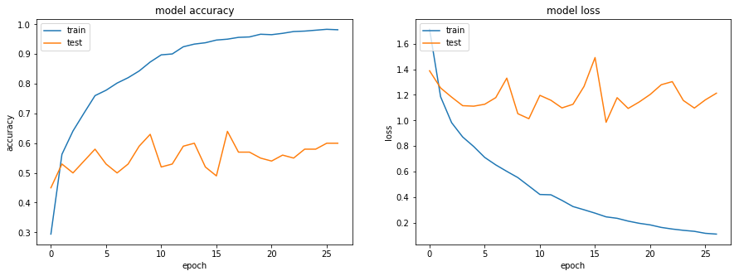

Experiments – 42 : CNN+RNN

Conv2D(32(3,3)) + BatchNormalization +

Conv2D(32(3,3)) + BatchNormalization +

Conv2D(32(3,3)) + dropout(.25) + kernel_regularizer=l2(.1)+ BatchNormalization +

MaxPooling2D((3, 3) strides=(2, 2) + BatchNormalization +

Flatten + dropout(.5) + GRU(64)

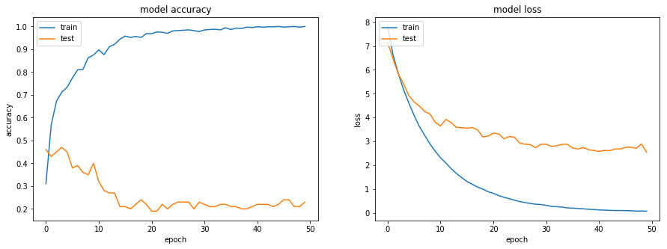

Experiments – 41 : CNN+RNN

Conv2D(32(3,3)) + BatchNormalization +

Conv2D(32(3,3)) + BatchNormalization +

Conv2D(32(3,3)) + dropout(.25) + kernel_regularizer=l2(.01)+ BatchNormalization +

MaxPooling2D((3, 3) strides=(2, 2) + BatchNormalization +

Flatten + dropout(.5) + GRU(64)

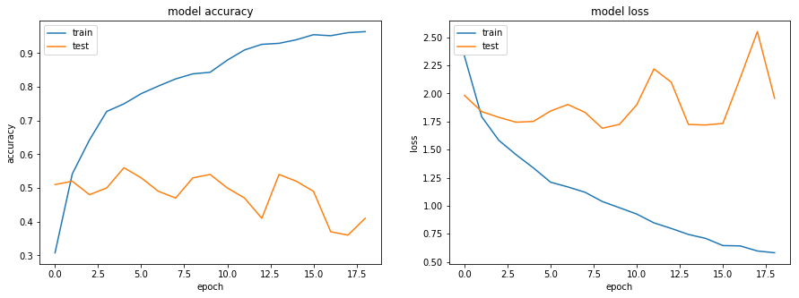

Experiments – 43 : CNN+RNN

Conv2D(32(3,3)) + BatchNormalization +

Conv2D(32(3,3)) + BatchNormalization +

Conv2D(32(3,3)) + dropout(.25) + kernel_regularizer=l2(.001)+ BatchNormalization +

MaxPooling2D((3, 3) strides=(2, 2) + BatchNormalization +

Flatten + dropout(.5) + GRU(64)

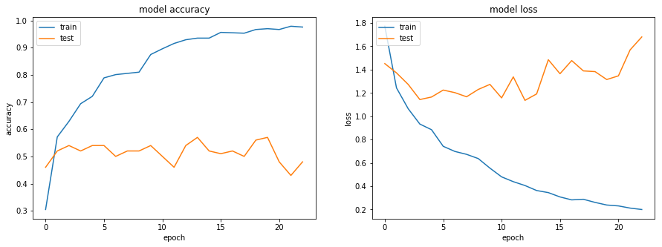

Experiments – 44 : CNN+RNN

Conv2D(32(3,3)) + BatchNormalization +

Conv2D(32(3,3)) + BatchNormalization +

Conv2D(32(3,3)) + dropout(.5) + kernel_regularizer=l2(.001)+ BatchNormalization +

MaxPooling2D((3, 3) strides=(2, 2) + BatchNormalization +

Flatten + dropout(.5) + GRU(64)

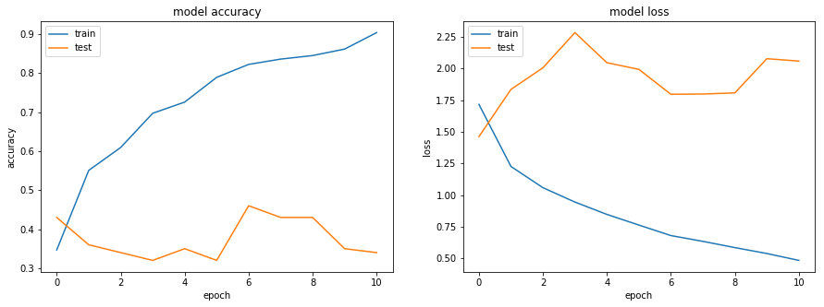

Experiments – 45 : CNN+RNN

Conv2D(32(3,3)) + BatchNormalization +

Conv2D(32(3,3)) + BatchNormalization +

Conv2D(32(3,3)) + BatchNormalization +

Conv2D(32(3,3)) + dropout(.5) + kernel_regularizer=l2(.001)+ BatchNormalization +

MaxPooling2D((3, 3) strides=(2, 2) + BatchNormalization +

Flatten + dropout(.5) + GRU(64)

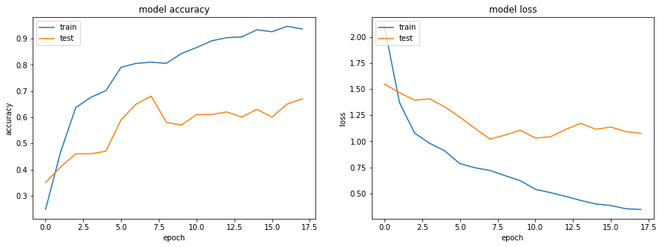

Experiments – 46 : CNN+RNN

Conv2D(32(3,3)) + BatchNormalization +

Conv2D(32(3,3)) + BatchNormalization +

Conv2D(32(3,3)) + BatchNormalization +

Conv2D(32(3,3)) + kernel_regularizer=l2(.001)+ BatchNormalization +

MaxPooling2D((3, 3) strides=(2, 2) + BatchNormalization +

Flatten + dropout(.5) + GRU(64)

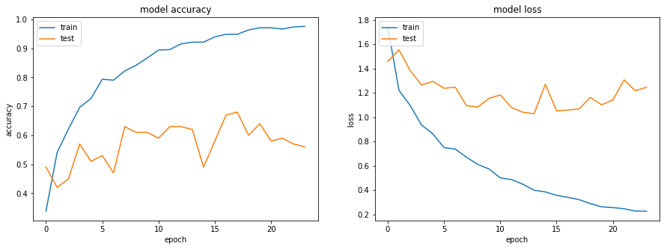

Experiments – 47 : CNN+RNN

Conv2D(32(3,3)) + BatchNormalization +

Conv2D(32(3,3)) + BatchNormalization +

Conv2D(32(3,3)) + BatchNormalization + kernel_regularizer=l2(.001)+

Conv2D(32(3,3)) + kernel_regularizer=l2(.001)+ BatchNormalization +

MaxPooling2D((3, 3) strides=(2, 2) + BatchNormalization +

Flatten + dropout(.5) + GRU(64)

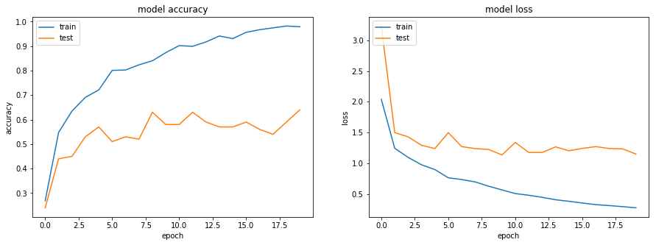

Experiments – 48 : CNN+RNN

Conv2D(32(3,3)) strides=(2, 2) + BatchNormalization +

Conv2D(32(3,3)) strides=(2, 2) + BatchNormalization +

MaxPooling2D((3, 3) strides=(2, 2)

Conv2D(32(3,3)) strides=(2, 2) + BatchNormalization +

Conv2D(32(3,3)) strides=(2, 2) + kernel_regularizer=l2(.001)+ BatchNormalization +

MaxPooling2D((3, 3) strides=(2, 2) + BatchNormalization +

Flatten + dropout(.5) + GRU(64)

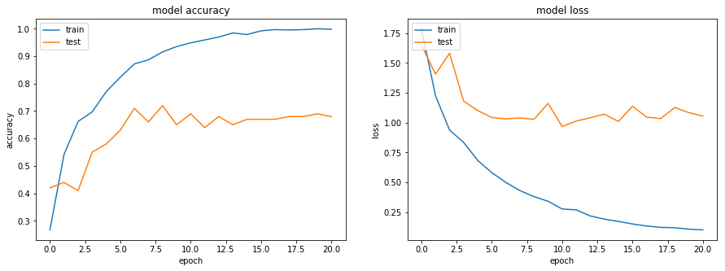

Experiments – 49 : CNN+RNN

Conv2D(32(3,3)) strides=(2, 2) + BatchNormalization +

Conv2D(32(3,3)) strides=(2, 2) + BatchNormalization +

MaxPooling2D((3, 3) strides=(2, 2)

Conv2D(32(3,3)) strides=(2, 2) + BatchNormalization +

Conv2D(32(3,3)) strides=(2, 2) + kernel_regularizer=l2(.001)+ BatchNormalization +

MaxPooling2D((3, 3) strides=(2, 2) + BatchNormalization +

Flatten + dropout(.8) + GRU(64)

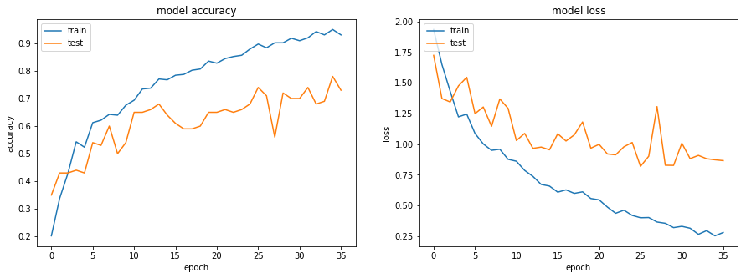

Experiments – 50 : CNN+RNN

Conv2D(32(3,3)) strides=(2, 2) + BatchNormalization +

Conv2D(32(3,3)) strides=(2, 2) + BatchNormalization +

MaxPooling2D((3, 3) strides=(2, 2)

Conv2D(32(3,3)) strides=(2, 2) + BatchNormalization +

Conv2D(32(3,3)) strides=(2, 2) + kernel_regularizer=l2(.001)+ BatchNormalization +

MaxPooling2D((3, 3) strides=(2, 2) + BatchNormalization +

Flatten + dropout(.9) + GRU(64)

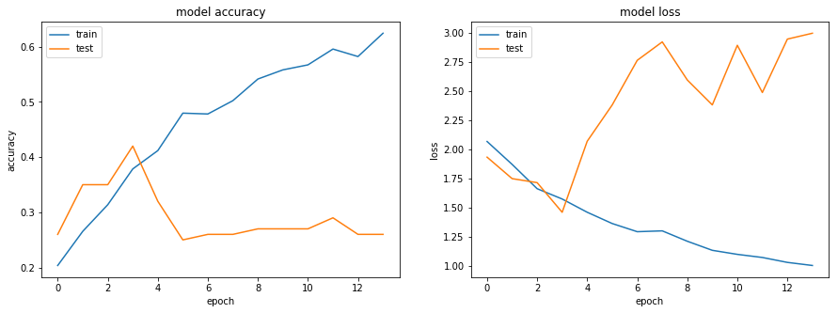

Experiments – 51 : CNN+RNN

Conv2D(32(3,3)) strides=(2, 2) + BatchNormalization +

Conv2D(32(3,3)) strides=(2, 2) + BatchNormalization +

Conv2D(32(3,3)) strides=(2, 2) + BatchNormalization +

MaxPooling2D((3, 3) strides=(2, 2)

Conv2D(32(3,3)) strides=(2, 2) + BatchNormalization +

Conv2D(32(3,3)) strides=(2, 2) + kernel_regularizer=l2(.001)+ BatchNormalization +

MaxPooling2D((3, 3) strides=(2, 2) + BatchNormalization +

Flatten + dropout(.8) + GRU(64)

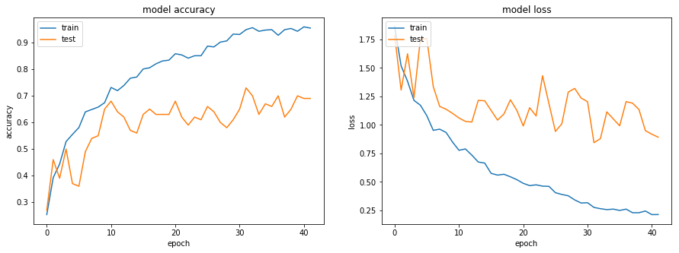

Experiments – 52 : CNN+RNN

Conv2D(32(3,3)) strides=(2, 2) + BatchNormalization +

Conv2D(32(3,3)) strides=(2, 2) + BatchNormalization +

Conv2D(32(3,3)) strides=(2, 2) + BatchNormalization +

MaxPooling2D((3, 3) strides=(2, 2)

Conv2D(32(3,3)) strides=(2, 2) + BatchNormalization +

Conv2D(32(3,3)) strides=(2, 2) + kernel_regularizer=l2(.001)+ BatchNormalization +

MaxPooling2D((3, 3) strides=(2, 2) + BatchNormalization +

Flatten + dropout(.9) + GRU(64)

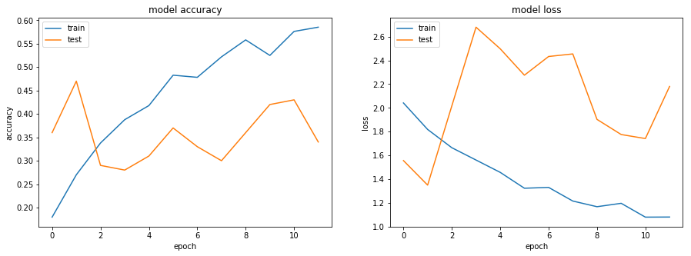

Experiments – 53 : CNN+RNN

Conv2D(32(3,3)) strides=(2, 2) + BatchNormalization +

Conv2D(32(3,3)) strides=(2, 2) + BatchNormalization +

Conv2D(32(3,3)) strides=(2, 2) + BatchNormalization +

MaxPooling2D((3, 3) strides=(2, 2)

Conv2D(32(3,3)) strides=(2, 2) + BatchNormalization +

Conv2D(32(3,3)) strides=(2, 2) + kernel_regularizer=l2(.001)+ BatchNormalization +

MaxPooling2D((3, 3) strides=(2, 2) + BatchNormalization +

Flatten + dropout(.8) + GRU(84)

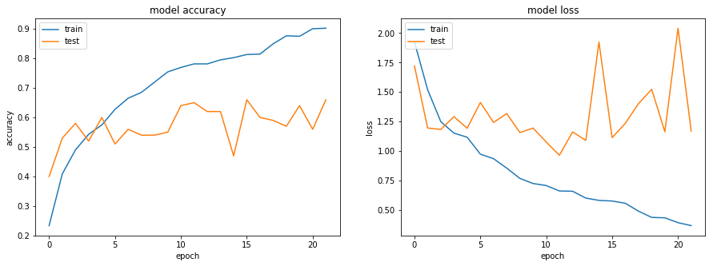

Experiments – 54 : CNN+RNN

Conv2D(32(3,3)) strides=(2, 2) + BatchNormalization +

Conv2D(32(3,3)) strides=(2, 2) + BatchNormalization +

Conv2D(32(3,3)) strides=(2, 2) + BatchNormalization +

MaxPooling2D((3, 3) strides=(2, 2)

Conv2D(32(3,3)) strides=(2, 2) + BatchNormalization +

Conv2D(32(3,3)) strides=(2, 2) + kernel_regularizer=l2(.001)+ BatchNormalization +

MaxPooling2D((3, 3) strides=(2, 2) + BatchNormalization +

Flatten + dropout(.8) + GRU(48)

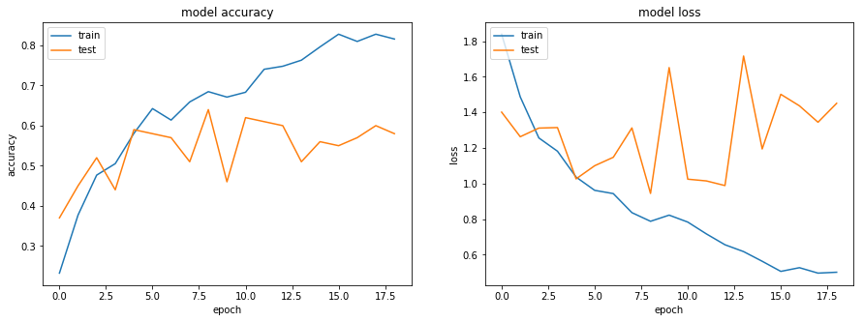

**Conclusion:**

**CNN: Experiments – No : 9**

jupyter_file name: Neural_Nets_Project_Starter_Code5

**Model: model-00024-0.09463-0.96380-0.66293-0.76000.h5**

Validation Accuracy: 76%, Training Accuracy: 95%



**CNN+RNN: Experiments – No: 49**

Neural_Nets_Project_Starter_Code18

**Model: CNN_RNN-model-00035-0.16339-0.95324-0.82417-0.72000**

Validation Accuracy: 72%, Training Accuracy: 95%

